**Parameter Estimation**

* Parameter estimation is the process of determining the values of unknown parameters in a statistical model based on observed data such as linear regression, exponential distribution, or Bayesian networks.
* The goal of parameter estimation is to find the most likely or best-fitting values for these parameters given the observed data.

**Parameter Estimation Methods**

Maximum Likelihood Estimation (MLE) and Least Mean Square Error (LMS) are methods used for parameter estimation in statistical and modeling contexts:

1. **Maximum Likelihood Estimation (MLE):**
   * MLE is a widely used method for estimating the parameters of a statistical model.
   * It seeks to find the parameter values that **maximize the likelihood function**, which measures how well the model explains the observed data.
   * In the context of parameter estimation, MLE aims to find the parameter values that make the observed data most probable under the assumed model.
   * MLE is commonly used in various statistical models, including **linear regression, logistic regression, exponential distribution, and Bayesian networks, among others**.

**Exponential Distribution**

Let's consider an example involving the time between the arrivals of customers at a service center, where we want to estimate the rate parameter (*λ*) for an exponential distribution.

**Scenario:** You manage a customer service center, and you are interested in modeling the time between customer arrivals at your center's reception desk. You want to estimate the average arrival rate (*λ*) of customers per hour using data collected over a week.

**Step 1: Collect Data:**

* Over the course of a week, you record the time intervals (in minutes) between customer arrivals at your service center's reception desk. Here are some example data points:

[12, 18, 9, 15, 23, 8, 11, 20, 14, 17, 22, 13, 10, 19, 16]

**Step 2: Formulate the Objective:**

* Your objective is to estimate the average arrival rate (*λ*) of customers per hour based on the collected data.

**Step 3: Choose a Criterion:**

* You decide to use Maximum Likelihood Estimation (MLE) to estimate *λ*. MLE will help you find the value of *λ* that maximizes the likelihood of observing the given time intervals between customer arrivals.

**Step 4: Estimate the Parameter:**

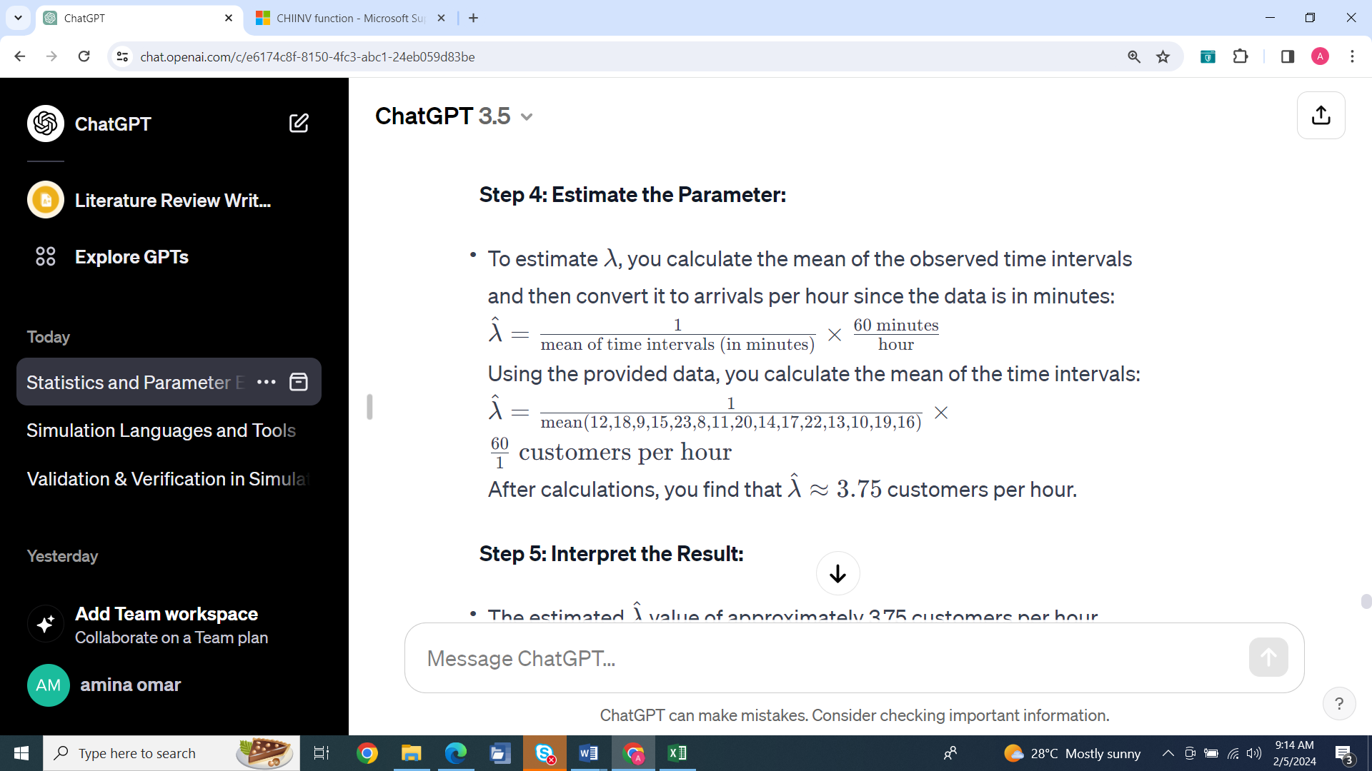

**Step 5: Interpret the Result:**

* The estimated *λ* value of approximately 3.75 customers per hour represents the average arrival rate at your service center's reception desk. It suggests that, on average, you can expect about 3.75 customers to arrive every hour.

**Step 6: Assess Model Fit:**

* To assess how well the exponential distribution fits the data, you can perform goodness-of-fit tests or create plots comparing the observed data to the fitted exponential distribution. These steps help you evaluate the quality of your parameter estimation.

In this example, you've estimated the rate parameter (*λ*) of the exponential distribution to describe the time between arrivals of customers at your service center. This estimation can help you make staffing and scheduling decisions to optimize customer service.

1. **Least Mean Square Error (LMS):**
   * LMS is a criterion used for parameter estimation, particularly in the context of linear regression.
   * In linear regression, the goal is to find the best-fitting linear equation that describes the relationship between independent and dependent variables.
   * LMS seeks to minimize the sum of squared differences (errors) between the observed values and the predicted values obtained from the linear model.
   * The estimated coefficients of the linear model are obtained by minimizing this mean squared error, resulting in the best linear fit to the data.
   * LMS is specific to linear regression but is a key method for estimating the coefficients (parameters) of the linear model.

In summary, both MLE and LMS are parameter estimation methods, but they are used in different statistical and modeling contexts. MLE is a general method used across various statistical models to estimate parameters that maximize the likelihood of the observed data, while LMS is specifically used in linear regression to estimate the coefficients of the linear model by minimizing the mean squared error

**Scenario:** Suppose you are interested in modeling the relationship between the number of hours spent studying (independent variable) and the test scores achieved (dependent variable) for a group of students. You want to estimate the parameters of a linear regression model to describe this relationship.

**Linear Regression Model:** The linear regression model assumes that the relationship between the independent variable (hours spent studying, denoted as X) and the dependent variable (test scores, denoted as Y) is linear and can be represented as:

*Y*=*β*0​+*β*1​*X*+*ε*

Where:

* *Y* is the predicted test score.
* *X* is the number of hours spent studying.
* *β*0​ is the y-intercept (the value of *Y* when =*X*=0).
* *β*1​ is the slope of the line (indicating how much *Y* changes for a one-unit change in *X*).
* *ε* represents the error term, accounting for the variability in *Y* that cannot be explained by the linear relationship.

**Parameter Estimation in Linear Regression:**

1. **Collect Data:** First, you collect data on the number of hours spent studying (*X*) and the corresponding test scores (*Y*) for a sample of students.
2. **Formulate the Objective:** The objective is to find the best-fitting values for the parameters *β*0​ and *β*1​ that minimize the differences (errors) between the predicted test scores and the actual test scores in the dataset.
3. **Choose a Criterion:** Typically, the least mean squared error (LMS) criterion is used in linear regression. The goal is to minimize the sum of squared differences between the observed test scores and the predicted test scores. The objective function to minimize is:

*L*(*β*0​,*β*1​)=Σ(*Yi*​−(*β*0​+*β*1​*Xi*​))2

Where *Yi*​ is the observed test score for the *i*-th student, and *Xi*​ is the number of hours spent studying by that student.

1. **Estimate the Parameters:** To estimate the parameters *β*0​ and *β*1​, you can use mathematical techniques such as the method of least squares. These techniques find the values of *β*0​ and *β*1​ that minimize the objective function *L*(*β*0​,*β*1​).
2. **Interpret the Results:** Once you've estimated the parameters, you can interpret them in the context of your problem. For example, you can say that for every additional hour spent studying (*X*), the test score (*Y*) is expected to increase by *β*1​ units, and the intercept *β*0​ represents the expected test score when no hours are spent studying.
3. **Assess Model Fit:** You can also assess how well the linear regression model fits the data by examining residuals (differences between observed and predicted values) and using measures like the coefficient of determination (2*R*2).

In summary, parameter estimation in linear regression involves finding the best-fitting values for the parameters (*β*0​ and *β*1​) that describe the linear relationship between variables. This is done by minimizing the mean squared differences between observed and predicted values, resulting in a model that explains the observed data as closely as possible.

Top of Form

**Parameter estimation in Bayesian networks**

Parameter estimation in Bayesian networks involves determining the conditional probability distributions (CPDs) for each node in the network based on observed data. Bayesian networks are graphical models that represent probabilistic relationships among a set of variables using a directed acyclic graph (DAG). CPDs specify how each variable depends on its parents in the graph. Here's how parameter estimation is performed in Bayesian networks:

**Step 1: Define the Structure of the Bayesian Network:**

* Before parameter estimation, you need to have a defined structure for the Bayesian network, which includes specifying the nodes (variables) and their conditional dependencies through a directed acyclic graph (DAG). The structure encodes which variables are parents or children of others.

**Step 2: Collect Data:**

* Gather a dataset that includes observations of the variables in your Bayesian network. This dataset will be used for parameter estimation.

**Step 3: Parameterize Conditional Probability Distributions (CPDs):**

* For each node in the Bayesian network, you need to specify its CPD. The CPD defines the probability distribution of the node given its parents in the DAG.

**Step 4: Choose a Parameter Estimation Method:**

* Several methods can be used for parameter estimation in Bayesian networks, including Maximum Likelihood Estimation (MLE), Bayesian Parameter Estimation, Expectation-Maximization (EM), and Bayesian Methods such as Markov Chain Monte Carlo (MCMC).
* The choice of method depends on the available data, the nature of the problem, and the specific requirements of the Bayesian network.

**Step 5: Estimate CPDs:**

* Depending on the chosen method, you estimate the CPDs for each node in the Bayesian network. The goal is to find the parameter values that best fit the observed data.
* For example, in MLE, you calculate the relative frequencies of different states of the node given the states of its parents based on the observed data.
* In Bayesian parameter estimation, you incorporate prior beliefs (prior distributions) and update them using the observed data to obtain posterior distributions for the parameters.

**Step 6: Model Validation:**

* After estimating the CPDs, it's important to validate the Bayesian network model. You can do this by assessing its predictive accuracy on new, unseen data, checking for model fit, and performing sensitivity analysis to assess the impact of parameter uncertainty.

**Step 7: Refinement and Iteration:**

* Depending on the results of model validation, you may need to refine the parameter estimates or the network structure and repeat the process iteratively until you achieve a satisfactory model.

Parameter estimation in Bayesian networks is a critical step in building probabilistic models that can be used for various applications, including decision support, classification, prediction, and reasoning under uncertainty. The choice of estimation method and the quality of the parameter estimates play a significant role in the accuracy and reliability of the Bayesian network model.

parameter estimation in a Bayesian network using a simplified scenario.

**Scenario:** Consider a Bayesian network that models the relationship between two variables: "Weather" and "Traffic." We want to estimate the conditional probability distribution (CPD) for the "Traffic" variable based on observed data.

**Step 1: Define the Structure of the Bayesian Network:**

- In this example, we have a simple Bayesian network with two nodes: "Weather" and "Traffic." The directed acyclic graph (DAG) shows that "Weather" is the parent node of "Traffic," indicating that weather conditions influence traffic.

**Step 2: Collect Data:**

- We collect a dataset over a month that records the "Weather" and "Traffic" conditions for each day. The "Weather" variable can take two values: "Sunny" or "Rainy," and the "Traffic" variable can take values: "Low," "Medium," or "High."

Here's a portion of the dataset:

| Day | Weather | Traffic |

|-------|---------|---------|

| Day 1 | Sunny | Low |

| Day 2 | Rainy | High |

| Day 3 | Sunny | Medium |

| ... | ... | ... |

**Step 3: Parameterize Conditional Probability Distributions (CPDs):**

- In Bayesian networks, CPDs are used to specify the probability distribution of each node given its parents.

- In our example, we need to parameterize the CPD for the "Traffic" node based on the values of its parent node "Weather." This involves estimating the conditional probabilities, such as P(Traffic = Low | Weather = Sunny), P(Traffic = High | Weather = Rainy), etc.

**Step 4: Choose a Parameter Estimation Method:**

- Let's use Maximum Likelihood Estimation (MLE) as our parameter estimation method in this example. MLE will estimate the CPD based on the relative frequencies observed in the dataset.

**Step 5: Estimate CPDs:**

- We calculate the MLE estimates of the conditional probabilities for the "Traffic" node based on the observed data. For example, if we observed 20 days with "Sunny" weather and "Low" traffic out of a total of 30 "Sunny" days, then:

\[P(Traffic = Low | Weather = Sunny) = \frac{20}{30}\]

Similarly, we calculate other conditional probabilities for different combinations of "Weather" and "Traffic" values.

**Step 6: Model Validation:**

- To validate the Bayesian network model, we can split the dataset into a training set and a test set. We use the training set to estimate the CPDs and then evaluate the model's predictive accuracy on the test set.

- Additionally, we can use graphical methods or statistical tests to assess the goodness of fit between the model and the observed data.

**Step 7: Refinement and Iteration:**

- Depending on the validation results, we may refine the parameter estimates or make adjustments to the network structure if needed. Iterative refinement can continue until we have a satisfactory model.

In this example, we demonstrated parameter estimation in a Bayesian network by estimating the CPD for the "Traffic" node based on observed data. Parameter estimation is a crucial step in building Bayesian network models that capture probabilistic relationships between variables and make them useful for various decision-making and inference tasks.

**LEAST MEAN SQUARE**

Least Mean Squares (LMS) is a widely used adaptive algorithm in signal processing and machine learning for estimating unknown parameters in a linear system. It is particularly useful when the statistics of the input signals are not known in advance or when the system is non-stationary.

**Basic Idea**

* **Objective**: Minimize the mean square error (MSE) between the desired output and the estimated output.
* **Update Rule**: Parameters are adjusted iteratively based on the gradient of the MSE.

In linear regression, the Least Mean Squares (LMS) algorithm can be used to estimate the coefficients of a linear model that best fits a given dataset. The goal is to minimize the sum of the squared differences between the predicted values and the actual values.

### Basic Idea

* **Model**: *y*=*w*0​+*w*1​*x*, where *w*0​ is the intercept and *w*1​ is the slope.
* **Objective**: Minimize the mean square error (MSE) between predicted and actual values.

